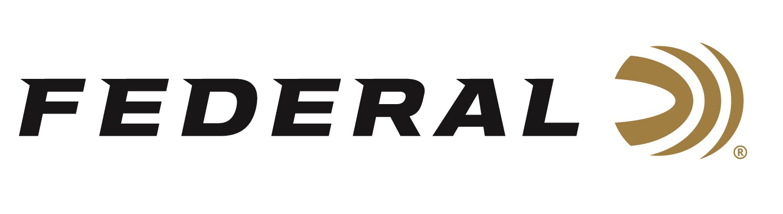
FOR IMMEDIATE RELEASE

Team Federal’s Derrick Mein Captures Silver Medal in Kazakhstan

ANOKA, Minnesota – May 11, 2026 – Two-time Olympian Derrick Mein claims a silver medal at the ISSF World Cup Shotgun event in Almaty, Kazakhstan. Competing on the international stage for Team Federal, Mein was in a highly contested Men’s Trap final on May 9 that went down to the last target. The event took place at the Asanov Shooting Club. The event kicked off on May 3 with opening ceremonies and concluded on May 10, 2026, following the Mixed Trap team competition.

A Turkish competitor had to set a new world record to grab the gold medal over Mein, who himself had his best finish at a World Cup event. “First time making a world level final with the new shotgun, it’s good to be back and out there competing for the win,” says Mein. The Kansas native started the final in the sixth position and steadily moved up the rankings with 19 consecutive targets broken. Mein missed the second to last target, while his Turkish opponent ran the last five targets clean. “It’s good to kick the season off like this, build some momentum for the summer and hopefully, I’ll be in Lonato and do the same,” says the 2-time Olympian in Men’s Trap.

Mein was the only male American competing at the ISSF World Cup Shotgun event in Kazakhstan. He teamed with Ava-Elizabeth Downs in the Mixed Trap Event.

Federal Ammunition products are available at dealers nationwide and online. For more information on all Federal products and to sign up to receive notifications about new product availability, rebate promotions, and other brand news via email, visit www.federalpremium.com.

Press Release Contact: JJ Reich
Senior Manager – Press Relations
E-mail: media@tkghunt.com

About Federal Ammunition
Federal, headquartered in Anoka, MN, is an ammunition brand of The Kinetic Group, owned by CSG, a globally diversified industrial group based in Prague, Czech Republic. Since 1922, Federal has been a leader in ammunition innovation, delivering high-quality sporting and hunting products to shooters worldwide. With a commitment to conservation and the outdoor community, Federal continues to manufacture industry-leading ammunition that enhances the shooting experience while supporting outdoor traditions.

